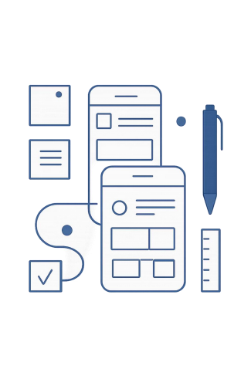
MODULE 06 · IT BUSINESS SOLUTIONS
UI/UX Principles &
Inclusive Design
Building on SAS 5 wireframes, this module teaches you to transform "screens that exist" into "screens that work" — applying visual hierarchy, accessibility, and inclusivity to create a consistent group prototype.
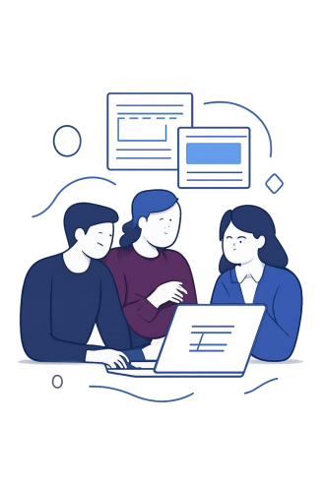
START OF LESSON · 10 MIN
Warm-Up: Reflect Before You Redesign Answer individually — these reveal what your group should review.
1
MVP Risk
What's the risk of polishing visuals before confirming layout clarity?
2
Empathy Insight
Name one user insight — what UI mistake happens if ignored?
3
TELOS Impact
Which TELOS category is most affected by confusing design?
4
Hardest Recall
Which question was hardest? What should your group review?
TRY IT OUT · 15 MIN
Categorize UX Issues: [H] · [A] · [I]
Read each scenario and tag it with its primary issue. Some overlap — choose the one causing the most harm.
9 Scenarios to Classify
1. Bright light, one-handed phone use 2. Low vision, text zoomed to 200% 3. No reading path — misaligned elements 4. Anxious user overwhelmed by choices 5. Blame language: "INVALID INPUT!" 6. Missing labels — placeholder only 7. Competing headlines
8. Tiny text, dense blocks
9. Assumes high literacy, no examples

[H] Hierarchy
Wrong thing stands out, clutter, no clear path

[A] Accessibility
Hard to see or use with limitations

[I] Inclusivity
Assumes one "normal" user, excludes edge cases
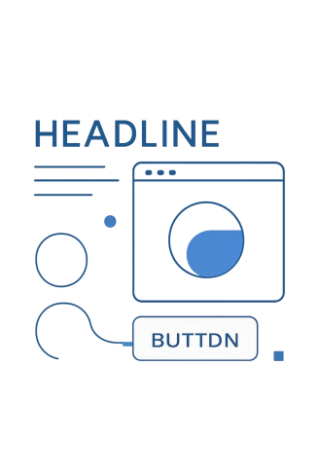
LET'S LEARN · PART A
Visual Hierarchy: What Stands Out First?
In SAS 5, wireframes answered "what goes where." Now answer "what stands out first and why?"
1 Priority Mapping
Must-do = primary action + required info. Nice-to-have = optional details. If everything looks important, nothing is.
2 Chunking & Grouping
Group into blocks (Requirements / Inputs / Actions / Feedback) with a heading per block.
3 Reading Path
Users scan top-to-bottom. Put the screen goal and requirements early.
LET'S LEARN · PART B
Accessibility: Design for Limitations
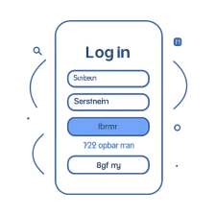
Accessibility ensures users can perceive and operate the interface under limitations — low vision,
zoom, motor control, glare, small screens.
Readable Structure
Short blocks, clear headings, avoid clutter
Text + Color Cues
Status and errors must have text cues — not color alone
Clear Labels
Buttons must say actions ("Submit Request"), not vague words ("OK")
Focus Order
Screen flow must match the task sequence
LET'S LEARN · PART B
Inclusive Design: Plan for Edge Cases Inclusive design supports users with low bandwidth, older phones, one-handed use, anxiety, and mixed literacy.
Avoid Blame Language
Instead of "Invalid!" use: "Enter an 8-digit ID (e.g., 20231234)."
Step Indicators
"Step 2 of 3" reduces anxiety and supports first-time users.
Provide Recovery
Always offer: retry, edit, back, or save draft.
Multiple Options
Offering more than one payment method supports different user realities.
LET'S PRACTICE · SESSION 1 · 20 MIN
Upgrade One Screen to V2
Choose One Screen
Select an Entry, Action, or Feedback screen from your wireframes. Apply Hierarchy
Edge-Case Support Examples


Save Draft option Low-bandwidth / lightweight version
• Add headings for blocks
• Move requirements above inputs • Make the primary action clearly dominant
Apply Accessibility + Inclusivity

Format examples (e.g., "MM/DD/YYYY")

Larger tap targets for mobile
• Clear labels, readable spacing • Text-based feedback cues • At least one recovery option • At least one edge-case support
Progress indicator for multi-step flows
Annotate your V2: label each improvement as [H], [A], or [I].
SESSION 2 · CONSISTENCY RULES
Make Screens Mergeable: 4 Rules
When members design separately, prototypes feel like different apps. Apply these rules so screens combine cleanly.
Rule 1: One Naming Convention
Pick one verb pattern (e.g., "Submit Request") and standardize across all screens.
Rule 2: One Screen Structure
Title → Instructions → Inputs → Primary Action → Feedback. Every screen follows this rhythm.
Rule 3: One Error Style
What happened → Why → How to fix. No blame language.
Rule 4: One Accessibility Baseline
Clear labels, readable spacing, text feedback, recovery option, edge-case support.
LET'S PRACTICE · SESSION 2
Group Integration: One Prototype, One Experience
Group
_{Integration} Individual V2
Mini
Usability
After upgrading all screens individually, your team merges them into one cohesive MVP prototype. Test the combined flow with another group member acting as a first-time user. The Observer may only ask: "What do you think you should do next?" and "What do you think happened after you clicked?"
WRAP-UP · 10 MIN
Reflect & Carry Forward Think Back
Carry-Forward to Module 7
Which UI/UX
improvement —
hierarchy, labeling,
accessibility, or feedback — made your screens clearest? How?
Which activity helped most: consistency kit, individual upgrade, or usability testing? How did
it change your thinking?
Your refined V2 screens will be integrated into your overall MVP and evaluated at the midterm checkpoint.
References
Interaction Design Foundation (2022). User flows and wireframing.
Knapp, Zeratsky & Kowitz (2020). Sprint: How to solve big problems in five days. Bantam.

